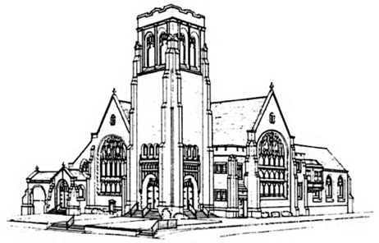
July 30, 2023
First Presbyterian Church
Ninth Sunday After Pentecost

Handbell Chimes—The ringing of the chimes invites you to a time of Rest…Renewal…Hope

Prelude Lucas Brown, piano

Opening Sentences
One: O sing to the Lord a new song;
All: sing to the Lord, all the earth.
One: Sing, and give praise to God’s name;
All: tell the glad news of salvation from day to day.

* Hymn #35 (insert) “Praise Ye the Lord, the Almighty”

* Invitation to Experience God’s Grace
One: The kingdom of heaven is for all of us, but we come to this space carrying many burdens. Let us confess our sins before our Triune God.

* Laying Down Our Burdens
All: Holy God, we are distracted people living in a distracting world. It is so hard to focus on you and be attentive to our neighbors and nature. Have mercy on us, O God. In your compassion, cleanse and release us from our sin. Create in us a clean heart, O God, a heart that burns for you. Renew a right spirit within us, a spirit of zeal for the restoration of the world. Amen.

* Silent Prayer

* Declaration of Forgiveness (based on Romans 8:34)
One: Who is to condemn? It is Christ who died and who was raised, who is at the right hand of God, who intercedes for us. In Jesus Christ, we are forgiven.
All: Thanks be to God! Amen.

* We Celebrate God’s Forgiveness Glory Be to the Father (Gloria Patri) #579
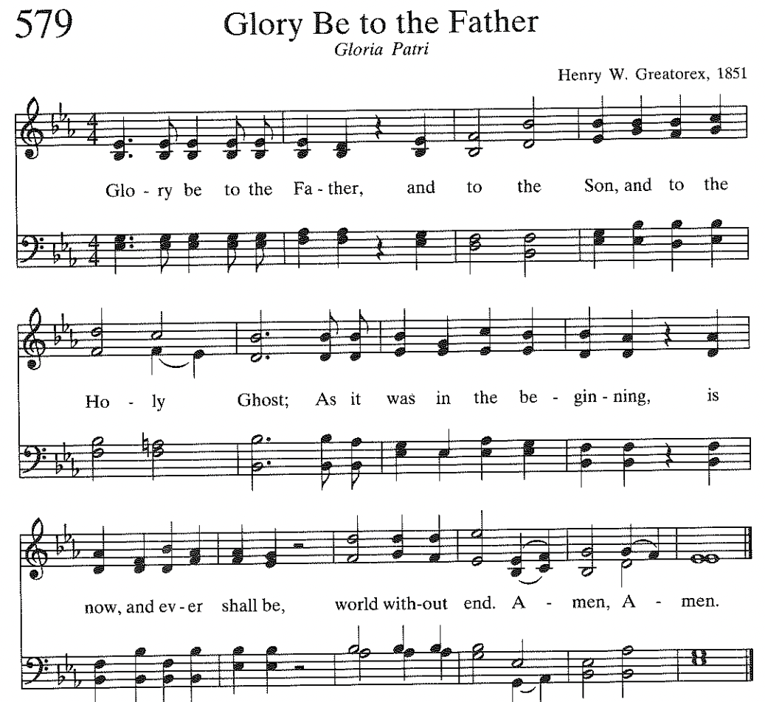

* Sharing the Peace of Christ

* Children’s Message

* Celebrating the life of the congregation

* Prayer for Illumination
All: Eternal God, you have made us in your image. Let our hearts, minds and spirits be turned to you in this time so that the Holy Spirit may bring us closer to the Word. Amen.

Scripture Reading: Genesis 29:14-30 (The Message)

14-15 Laban said, “You’re family! My flesh and blood!” When Jacob had been with him for a month, Laban said, “Just because you’re my nephew, you shouldn’t work for me for nothing. Tell me what you want to be paid. What’s a fair wage?”

16-18 Now Laban had two daughters; Leah was the older and Rachel the younger. Leah had nice eyes, but Rachel was stunningly beautiful. And it was Rachel that Jacob loved. So Jacob answered, “I will work for you seven years for your younger daughter Rachel.”

19 “It is far better,” said Laban, “that I give her to you than marry her to some outsider. Yes. Stay here with me.”

20 So Jacob worked seven years for Rachel. But it only seemed like a few days, he loved her so much.

21-24 Then Jacob said to Laban, “Give me my wife; I’ve completed what we agreed I’d do. I’m ready to consummate my marriage.” Laban invited everyone around and threw a big feast. At evening, though, he got his daughter Leah and brought her to the marriage bed, and Jacob slept with her. (Laban gave his maid Zilpah to his daughter Leah as her maid.)

25 Morning came: There was Leah in the marriage bed! Jacob confronted Laban, “What have you done to me? Didn’t I work all this time for the hand of Rachel? Why did you cheat me?”

26-27 “We don’t do it that way in our country,” said Laban. “We don’t marry off the younger daughter before the older. Enjoy your week of honeymoon, and then we’ll give you the other one also. But it will cost you another seven years of work.”

28-30 Jacob agreed. When he’d completed the honeymoon week, Laban gave him his daughter Rachel to be his wife. (Laban gave his maid Bilhah to his daughter Rachel as her maid.) Jacob then slept with her. And he loved Rachel more than Leah. He worked for Laban another seven years.

One: Holy wisdom, holy Word.
All: Thanks be to God.

Sermon "What Comes Around Goes Around"

We Affirm our Faith (from The Confession of Belhar)
We believe:
    - that God has entrusted the church with the message of reconciliation in and through Jesus Christ;
    - that the church is called to be the salt of the earth and the light of the world, that the church is called blessed because it is a peacemaker, that the church is witness both by word and by deed to the new heaven and the new earth in which righteousness dwells;
    - that God’s life-giving Word and Spirit has conquered the powers of sin and death, and therefore also of irreconciliation and hatred, bitterness and enmity, that God’s life-giving Word and Spirit will enable the church to live in a new obedience which can open new possibilities of life for society and the world.

GIVE THANKS TO GOD

Prayers of the People

The Lord’s Prayer
Our Father who art in heaven, hallowed be thy name. Thy kingdom come, thy will be done, on earth as it is in heaven. Give us this day our daily bread; and forgive us our debts, as we forgive our debtors; and lead us not into temptation, but deliver us from evil. For thine is the kingdom and the power and the glory, forever. Amen.

Practicing Abundant Generosity https://onrealm.org/FirstPresbyteri11244/give/now

Offertory: "I Love to Tell the Story" by Arabella Katherine Hankey
Bud Miller, tenor
Please join with Bud to sing the chorus at the end of each verse (below)
* Doxology
* Recommitting Our Lives to Service
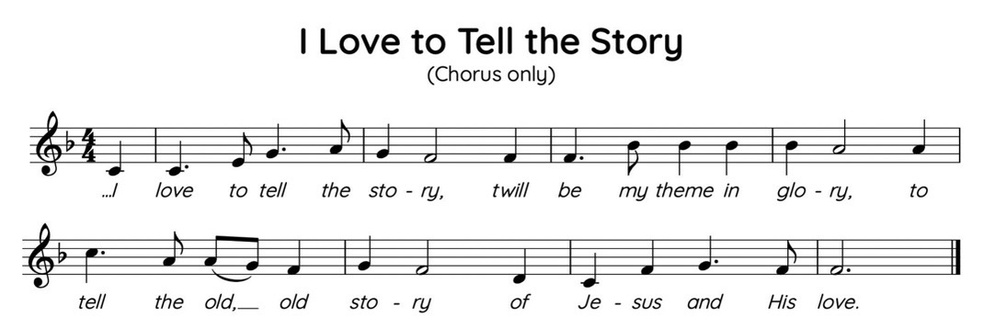

* Prayer of Dedication

* Hymn #735 (insert) “I Need Thee Every Hour”

LEAVE TO SERVE

* Charge and Benediction

Sending Music Lucas Brown, piano

Please use the Postlude time and music to reflect on today’s worship experience and how it will support you in the week to come.

Notes for Bulletin:
Reprinted / Podcast / Streamed with Permission Under
OneLicence #740987-A.
All Rights Reserved.

Portions of today’s service are adapted from a liturgy written by Jo Wiersema and provided for free distribution. © Presbyterian Outlook, 2023.

WELCOME TO FIRST PRESBYTERIAN CHURCH! It is good to have you here in person or online. Please be in touch if you have news to share or would like more information or to talk to a pastor. Staff contact information is below. Read full announcements in our weekly email newsletter, available on the church website. Subscribe on the Contact Us tab.

THE NURSERY care is available in the Hospitality Center – across from Fellowship Hall.

AFTER-WORSHIP HOSPITALITY IS BACK! Linger a moment or two after the service to greet fellow worshippers. And please sign up with a friend or a group to host one Sunday by providing simple refreshments. There is a sign-up on the snack table or contact someone on the Hospitality Committee: jmfiorella@gmail.com, shoemakerjanet68@gmail.com, qlerch2@comcast.net, or phurd75@gmail.com,

PASTOR NIKKI LEADS SUMMER WORKSHOP SERIES– This summer Pastor Nikki is offering three, one-hour workshops after Sunday worship in the Hospitality Center. Light snacks will be provided as well as ample time for questions and discussion!
Sunday August 13: Gun Violence
The Presbyterian Outlook is dedicating its June issue to the topic of gun violence. The Christian Education and Justice and Advocacy committees invite you to join a discussion on August 13. Copies of the issue will be available.

PASTOR NIKKI’S BIBLE STUDY THURSDAYS @ 7 – Pastor Nikki is hosting a Bible Study via Zoom on the book of Genesis entitled “Genesis: Relational and Family Dynamics.” The reading schedule is linked on the Adult Ed page of the website. The Zoom link is https://us06web.zoom.us/j/81798184993, and we will also meet in person at pre-determined times. Please contact Pastor Nikki if you have questions and are interested or join us on Zoom!

The August Porch Bible Study will meet in the Bean Parlor at 4 p.m., on Tuesday, August 15. Our August Porch Lunch will be Tuesday, August 8, at noon at Mulligan's Bar and Grill in Oaklyn. For more information, contact Deb Nussbaum at debranussbaum1987@gmail.com.

I Love to Tell the Story was a poem, written by Arabella Katherine (Kate) Hankey (1834-1911) in 1866 and was put into music by William G Fischer, and first published in a hymnal in 1869. Kate had a heart for missions and donated all of her income to missions work. She served as a missionary in Africa with her brother. – Bud Miller

WORSHIP ATTENDANCE 7/16/23: 92 in person and 2 online.

2023 CHURCH OFFERING UPDATE – Please note that target numbers on the right now represent a 12 month budget.
Received to date Twelve-month budget goal
Envelope Giving: $ 359,232.00 $ 570,270.00
Loose Offering: $ 6,750.00 $ 12,000.00
Per Capita: $ 8,777.00 $ 16,000.00

CONGRATULATIONS if you were PLASTICS FREE IN JULY! Even if you succeeded in reducing your use of plastics, you’ve taken an important step. We all need to keep working on eliminating the demand for plastics. Not easy but necessary. Whether it’s a plastic bottle that ends up in our waterways, a child's toy sitting in a landfill, or even the shirt you're wearing right now — plastics break down and shed microplastic fibers that we consume through our water and air.
Scientists have now found microplastics in the crops we grow, in our drinking water, in the air we breathe, and within our bodies. One reason this is so concerning is the many toxic chemicals used to make plastics or added to them, including PFAS “forever chemicals.” Food & Water Watch also
reports that an average person swallows about a credit card worth of plastic a week!
There is good news! Amazon just announced that they're phasing out plastic padded shipping envelopes in favor of recyclable options. As the world's largest online retailer, Amazon's packaging is a big piece of the plastic waste puzzle. Amazon still needs to commit to a concrete timeline for phasing out these plastic envelopes. Remember that while recycling is important, Reducing then demand for plastics is most important.

Worship Activity Bags are now available for children attending worship in
Fellowship Hall this summer. The bags contain coloring sheets and crayons and may be taken home. Children are encouraged to draw on the bags themselves as well as the enclosed activity sheets.

Backpack fillers needed for St Wilfrid’s! We have 91 backpacks for St. Wilfrid’s and need a few more items to fill them…
2 pocket folders- 20
Kids’ scissors- 40
Pencil cases- 20
Thank you for your donations.
Items may be dropped off on Corey Crumley’s porch at 40 Warwick Rd. Haddonfield

American Red Cross will be having a blood drive in Fellowship Hall on Friday, September 1st, 2023, from 12:00 PM to 5:00 PM. To schedule an appointment, visit redcrossblood.org and enter sponsor code: First Presbyterian Church

Did you go to Kentucky in 2022? Do you have your tee shirt you are no longer using? If so, please text me, Margot Dark, at 609-238-0694. I am trying to make a quilt with all Drew's mission trip tee shirts, and he still likes wearing Kentucky. Thank you!

Haddonfield residents concerned about fire safety should contact either the Haddon Fire Company at 856-429-4308, or Travis Bogetti at 856-429-1960 to arrange for a member of the Fire Company to visit your home and conduct a free safety inspection.

CONGREGATIONAL PRAYER LIST

Please pray for the following individuals and situations throughout the week. If you would like to add a personal prayer request, please contact one of the pastors or our new Office Administrator, Olivia Willison. Requests will be revisited every 30 days.
Prayers for the Church
- Pray for the people, government, and country of Ukraine as war continues.
- Pray for Al Ritchie who is recovering from a fall, and pray also for Ginny and her family (7/27-pastors)
- Pray for Francie’s mom who has gone home to be on hospice (7/25-L. Sommers)
- Continued prayers for Susan, who has been diagnosed with brain cancer and a mass in lungs. Help her to feel God’s presence and strength (7/24-C. Carty)
- Prayers for Ebony that she will find a healthcare provider who will listen (7/24-L. Kirsch)
- Please pray for courage and strength for Nancy as she continues with her cancer treatments (7/20-C. Carty).
- Prayers of comfort for Barbara as she grieves her husband Don (7/19-C. Carty).
- Please pray for the Andreski family as they grieve for Nancy, their beloved wife and mother (7/18- C. Carty)
- Pray for 19-year-old Cole. Cole has battled cancer twice, and was recently diagnosed with a brain tumor and underwent emergency surgery. He is recovering! Pray for continued recovery and full healing! (7/13- T. Adkins)
- Please pray for health and healing for Dottie Peatman (7/12- M. Westermaier)
- Pray for God’s provision and protection over Philip’s upcoming trip home (7/10-P. Chang)
- Please pray for Jason Gilbert who suffered a fall and cut his head. He is being monitored for internal bleeding. Pray for healing! (7/7-M. Dark)
- Please pray for Amy and Brad Strauss, that God would be present in their lives (7/7-pastors).
- Please pray for the ladies incarcerated in Camden County Jail, with specific attention on their living conditions that they would be more rehabilitative, and that they would get to go outside more often (7/6-G. Ladies)
- Please pray for Tiffany, Summer, and Julia; and for their children and grandchildren, and that they will be together soon (7/3-G. Ladies)
- Pray for Carly, her boyfriend John, and her safety (7/2-G. Ladies)
- Please pray for Morgan and Tanisha and their children (7/1-G. Ladies)
- Pray for Jennifer. God knows the needs (6/30-N. Passante)
- Keep Isabel Pross in your prayers as she undergoes cancer treatment (6/27-pastors)

Church Staff
The Rev. Dr. Marvin Lindsay, Senior Pastor and Head of Staff – mlindsay@haddonfieldpres.org
The Rev. Nikki Perrine Passante, Associate Pastor – npassante@haddonfieldpres.org
Peter Leibensperger, Minister of Music – pleibensperger@haddonfieldpres.org
Lucas Brown, Principal Organist – lbrown@haddonfieldpres.org
Katie Beth McBurnie, Director of Children’s Ministry – kmcburnie@haddonfieldpres.org
Nancy Ruth Wainwright, Director of Children’s Choirs – nancyruthw@comcast.net
Marisa McGovern, Preschool Director – preschool@haddonfieldpres.org
Kris Bean, Business Manager – kbean@haddonfieldpres.org
Travis Bogetti, Building Manager – tbogetti@haddonfieldpres.org
Ed Hess, Community Caseworker – edwh517@aol.com
Olivia Willison — officeadmin@haddonfieldpres.org

